STUDENT ID: 220455224

MACHINE LEARNING ST3189 COURSEWORK REPORT
Contents
Data Selection 2
Steps to be Implemented for Every Technique 2
Unsupervised Learning 2
K-means Clustering 3
Hierarchical Clustering 3
Compare k-means Cluster to Hierarchical Cluster 4
Visualisation Using Results From k-means 5
Show How Flat Type Affect Variables 5
Classification Techniques 5
Decision Tree 6
Multinomial Logistic Regression 7
Comparison between Decision Tree and Multinomial Logistic Regression 8
Regression Technique 8
Multiple Linear Regression 9
Random Forest 10
Comparing Multiple Linear Regression and Random Forest 10
Predictions with Multiple Linear Regression 10
Additional Check 10
Conclusion 11
References 12

Data Selection
For this report, I have chosen to use 2 different data sets.
The first dataset is ‘Resale Flat Prices’ from data.gov.sg which shows resale flat prices from 1990 to 1999 and their attributes such as town, flat type, block, floor area, flat model etc. I intend to use this dataset to showcase unsupervised learning techniques and classification techniques.
The second dataset is ‘Global Food Wastage’ from Kaggle which shows global food wastage from 2018 to 2024. It includes data such as country, year, total wastage, population, etc. I intend to use this dataset to show regression techniques.

Steps to be Implemented for Every Technique
Ensure that after opening the R markdown file, set the working directory to where the respective dataset is located. Afterwards, install and load the packages required to run the codes. Lastly, run the code that reads the file containing the dataset into a data frame.
Each technique has its own unique set of packages that will be used, so run the above steps for each technique.

Unsupervised Learning
Research Question: Can we cluster houses by flat types? How does flat type affect variables?
We will be using k-means and hierarchical clustering for this question. We chose to use k-means as it is well-suited for datasets with continuous numerical features like resale price, floor area. K-means is a distance-based algorithm which is good when the clusters formed are well-separated and compact, which might be the case for flat types. Usually having a bigger flat or a flat with a greater number of rooms tend to have higher resale prices, this might lead to the formation of distinct clusters. Hierarchical clustering allows us to graph a dendrogram for better visualization, to better understand the relationships between clusters and capture hierarchical relationships.
As the dataset is huge, we will do only 2 years, 1990 and 1991. However, the steps written are applicable to all the years. Firstly, we need to extract the year from the month column as currently it is written as YYYY-MM. After extracting, we filter out rows from 1990 to 1991.
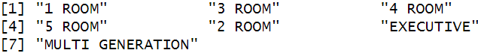
Our target variable is flat types, so we need to check how many categories there are for flat type. Afterwards, convert flat type to numeric to be used for clustering.
As there are many columns, we will be selecting only flat type, floor area and resale price to be used. Ensure that we remove missing values if there are any as it will affect our results. Next, we take a random sample of 10000, then normalise the data. Normalising the data is crucial as k-means and hierarchical clustering rely on distance-based measurements, in this case, Euclidean distance. Normalisation ensures that all variables contribute equally to the clustering process. In this dataset, different variables have different scales. For example, resale prices are in the thousands while floor area is from the tens to hundreds. Without normalisation, resale price will dominate the clustering process which makes the clustering biased towards it.

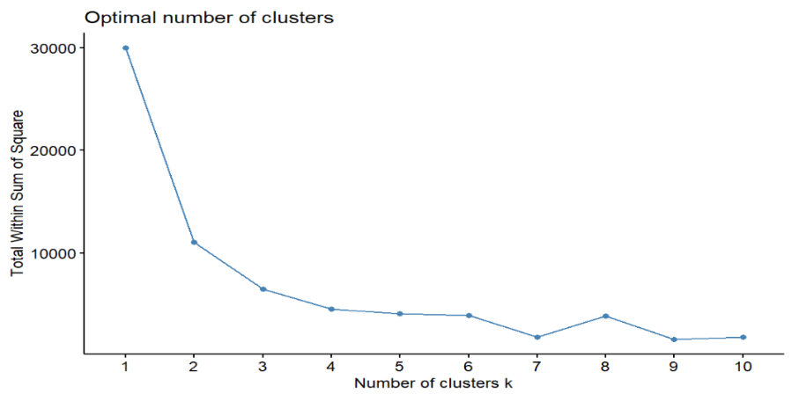
K-means Clustering
We will determine the optimal number of clusters using the elbow method. Plot the Within-Cluster Sum of Squares (WCSS) against the number of clusters (k). WCSS measures how spread-out points are within each cluster. The lower the WCSS, the closer the data points are to their centroids thus better clustering. Based on the graph formed, we observe that there is a slight elbow at k=2. However, 2 is quite a small number of clusters, so we will use k=3 to capture more diversity. We also do not want to use too many clusters as an increase in the number of clusters will reduce WCSS less than proportionately. It is not worth using k=10 clusters as it will be harder to interpret which is not worth is for such a minor decrease in WCSS.
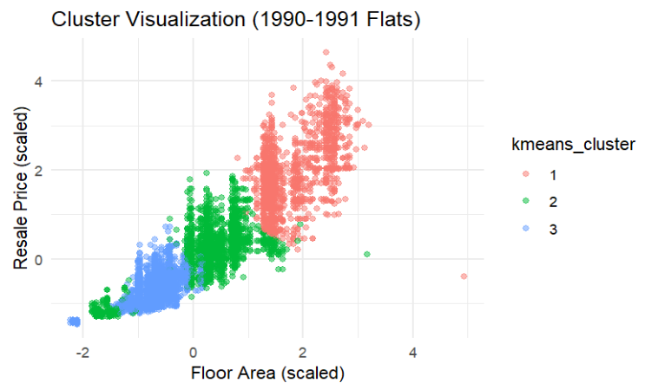
Add k-means cluster labels to the data frame to allow us to do a comparison for hierarchical clusters to k-means clusters later.
To visualize the clusters, we graph a cluster plot. Do note that since we used a sample, the cluster labelling might switch each time we run the code. We see that cluster 1 contains flats that are biggest in floor area and highest in resale price. Cluster 2 contains flats that are in the middle range for both resale price and floor area. However, there is a part of cluster 2 which has a very small floor area and low resale price. Cluster 3 has the smallest floor area and the lowest resale price, excluding parts of cluster 3. We observe that there are some overlaps in the clusters, meaning that some data points in these clusters share similar characteristics. They might be better separated when k is a bigger number. At k=3, WCSS is 6428.931.

Hierarchical Clustering
As hierarchical clustering works by merging or splitting clusters based on their similarity, we need to compute the Euclidean distance beforehand, as it measures the closeness between data points. Ward’s method works by minimizing variance when merging clusters. At each step, two clusters will be merged if they result in the smallest possible increase in variance.
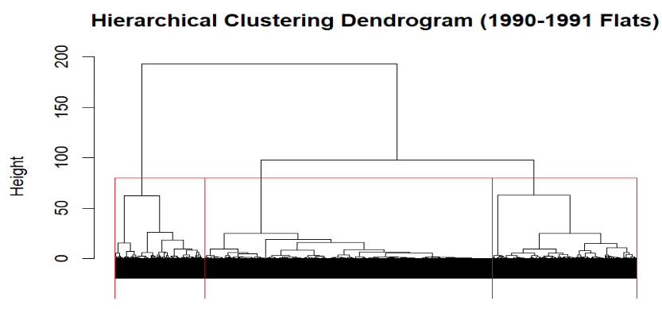
Plot the dendrogram and add rectangle to the dendrogram for better visualization on where we are cutting the dendrogram. Add hierarchical cluster labels to the scaled data frame.

Compare k-means Cluster to Hierarchical Cluster
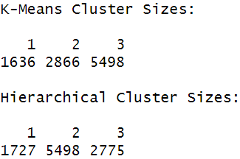
Create a table to check the number of flats in each cluster. For k-means clusters, there are 1636, 2866, 5498 flats in cluster 1, 2, 3 respectively. For hierarchical clusters, there are 1727, 5498, 2775 flats in cluster 1, 2, 3 respectively. Clearly, in different techniques, clusters were labeled with different numbers. To solve this, we find the mean of each variable in each cluster then compare the two techniques against one another.
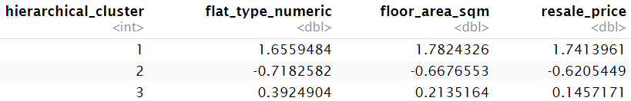
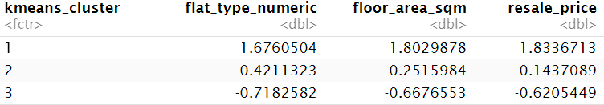
Using floor area, we observed that k-means cluster 1 (1.8029878) has the closest means to hierarchical cluster 1 (1.7824326). However, k-means cluster 2 (0.2515984) and 3 (-0.6676553) have the closest means to hierarchical cluster 3 (0.2135164) and cluster 2 (-0.6676553) respectively. To further prove this statement, use this method on the other two variables and we would see that the statement is correct. We need to reassign the hierarchical clusters. After reassigning, do a check just to make sure there are no errors before we proceed.
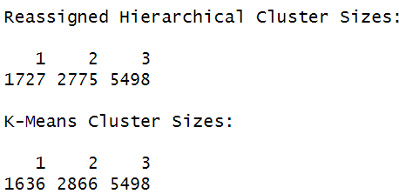
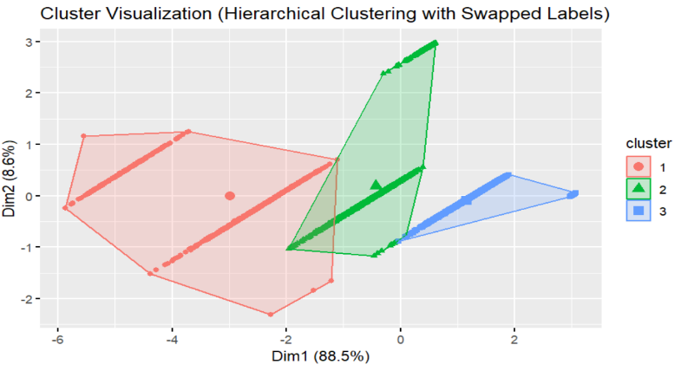
Visualize the updated hierarchical clustering. Dim1 is principal component (PC) 1, which is the direction that captures highest variance in the data while Dim2, which is PC2, is the next highest variance in the data. PC1 accounts for 88.5% of the total variance in the dataset while PC2 accounts for 8.6%. PC1 and PC2 combined explain 97.1% of the total variance, proving that most of the information in this dataset is preserved in this 2D projection. We observe that cluster 1 and 2 overlaps more than cluster 2 and 3.
Compare cluster sizes between the two techniques to check if they are correctly assigned.
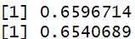
Now, we compare which technique is better for this data set by using silhouette score. Higher values indicate better-defined clusters. From the result, we see that k-means clustering is better as it has a value of 0.6596714 while hierarchical clustering has a value of 0.6540689.

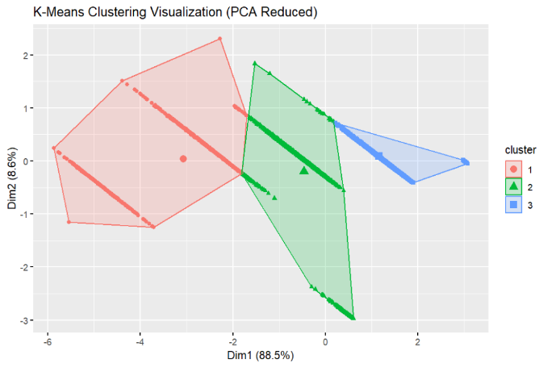
Visualisation Using Results From k-means
Firstly, perform principal component analysis (PCA) on the scaled data and visualize the clusters using the k-means cluster labels. We need to do PCA before visualization as it will help reduce complexity while maintaining the structure of the dataset. Additionally, it helps to check how well k-means has grouped similar points. From the graph, we see that the two dimensions still represent 97.1% of the data and the clusters are more well separated now.

Show How Flat Type Affect Variables
Now that we know that we can cluster houses with flat type. We can use it to see how flat types affect different variables.
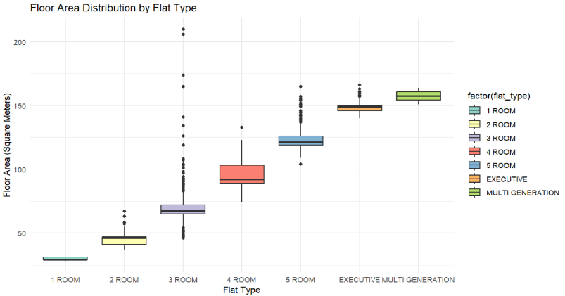
Plot a boxplot to visualise floor areas by flat types. We observe that flats with 3 rooms have the greatest number of anomalies with some having bigger floor area compared to flats that has more rooms. Overall, the trend is as the number of rooms increases, the floor area increases. Multi-generation flat type has the biggest floor area followed by executive.
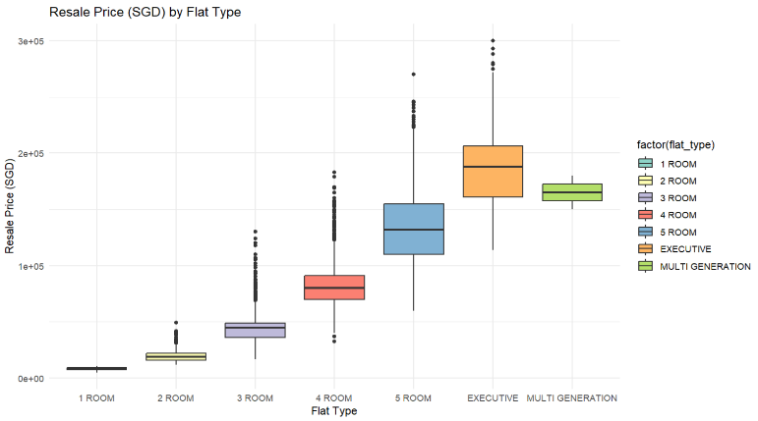
Plot a boxplot to visualize how resale prices change with the type of flat. In general, as the number of rooms increases, the resale price increases. This stops at multi-generation flat type, as multi-generation flat type has a lower mean resale price than executive. The most expensive flat type is executive.

Classification Techniques
Research question: Can we predict the flat model based on features like floor area, resale price, lease commence year and flat type?
In Singapore, the Housing Development Board offers a range of flat models to accommodate various household sizes and financial needs (Housing & Development Board). Improved flat model are bigger, for example 3 room standard flats are 54 to 71sqm while improved 3 room flats are 60 to 76sqm (Shashi Kumar, 2024). Model A 3 room flats were 73 to 75sqm. Multi-generation flats have 3 bedrooms and a studio with 2 entrances (Singapore Housing Map). These are just some examples of the different flat models in Singapore in the 1990s. As we want to predict the flat model, we will be using floor area, resale price, lease commencement year and flat type as these are the main factors that are affected by the flat model.
We will be using decision tree and multinomial logistic regression. Decision tree can capture non-linearity but can be quite complex if the tree has a lot of splits. Multinomial logistic regression is simple to interpret which will boost our understanding of the model, however it assumes linear relationships between flat model and the other variables.
First, we extract the years we want to use which are 1992 and 1993. Afterwards, convert the categorical variables, flat model and flat type, into factors. This is to ensure proper encoding in the models, R might assume categorical variable as a continuous variable if its not convert to factors, leading to incorrect results being produced. Create an updated data frame that contains the data we need; this is to speed up the loading process. Check the updated data frame. Next, split the data sets into training and testing sets. 70% of the data set will be used for training, 30% will go to testing set. Check if there are any NA values in training data, we must ensure that there are none.

Decision Tree
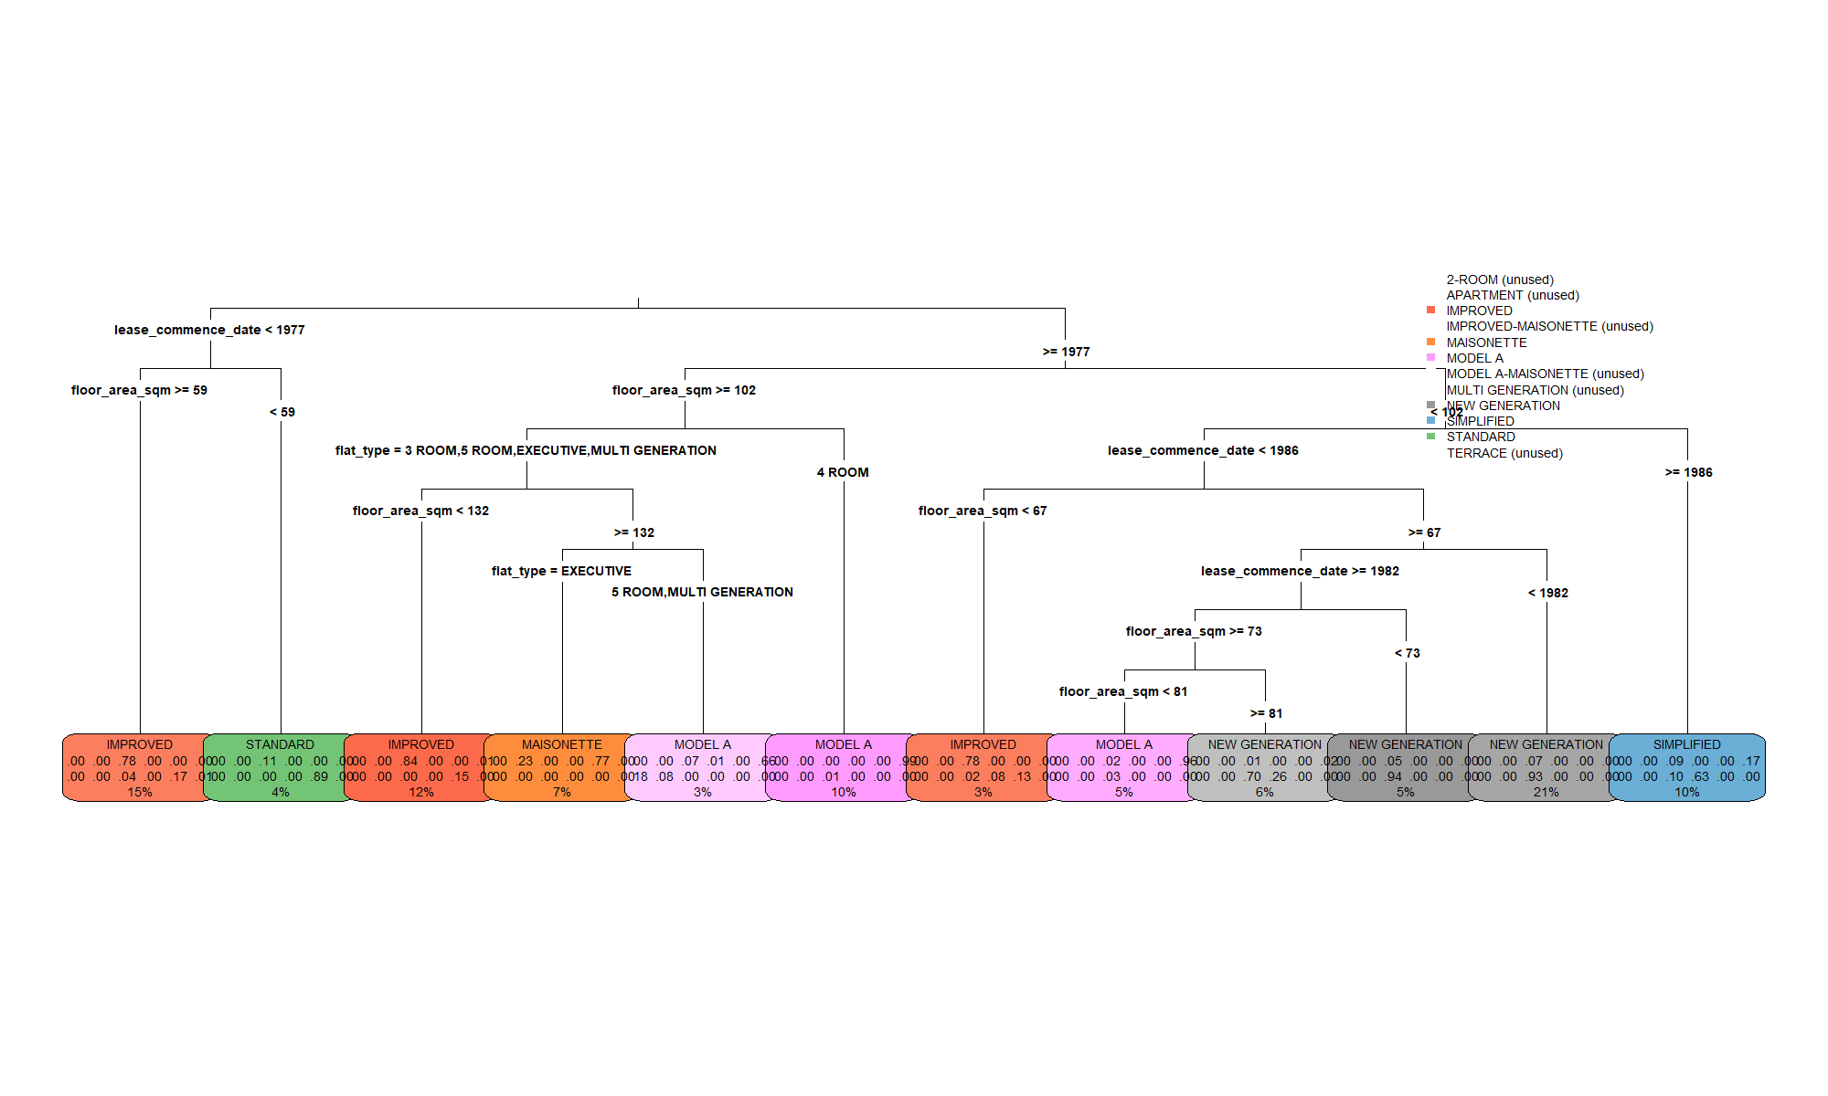
First, we train the decision tree model and plot the decision tree. We observe that there are many splits, and we cannot read the labels. To solve this, we must prune the tree. I have also opted to saving the decision tree into png such that we can zoom in and view the labels better. We look at the node with the most complex splits. Firstly, it is split by lease commence date of before 1977 or 1977 onwards, then by floor area below or 102sqm onwards. It is further split by lease commence date of before or 1986 onwards. This pattern is repeated until it ends with the node that represents 6% of the dataset (4th rightmost node). There is a 70% chance that the flat model in this node is new generation, 1% chance that it is a improved flat model, 26% chance that it is a simplified flat model. Nodes with darker shade means the model has higher confidence in its classification.

Multinomial Logistic Regression
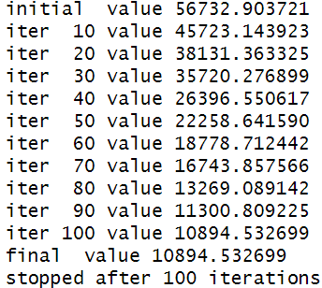
Build the model. We observed that the loss function decreased significantly from 56732.903721 to 10894.532699 after 100 iterations, which tells us that the model has improved its fit.
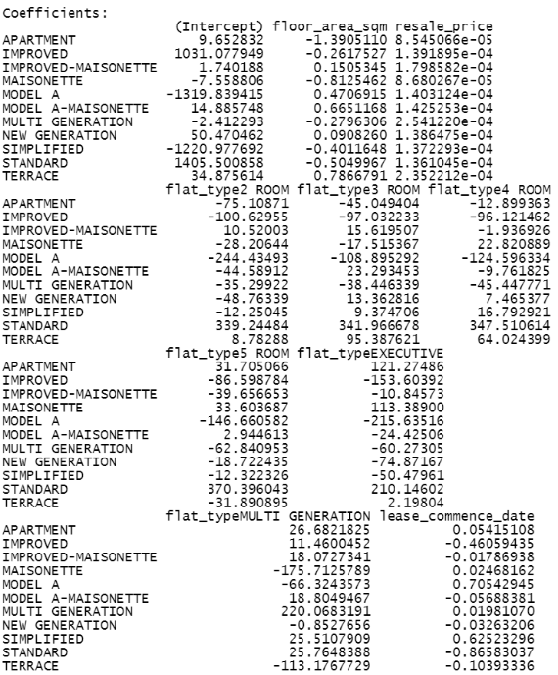
Residual deviance measures how well the model fits the data. It is based on log-likelihood and calculated as Residual Deviance = -2 x log(Likelihood of the model) . We want to check if the predictors, which are flat type, lease commence date, floor area and resale price provide any explanatory power so we must find the null model residual deviance. The null model is a model with no predictors to explain the flat model. The null model residual deviance is 77755.48, showing that it does a poor job of explaining the data. Null Deviance – Residual Deviance = 77755.48 – 21789.07 = 55966.41. This large difference tells us that these predictors provide great explanatory power.
Now, we look at the coefficients. Each coefficient shows the log-odds of choosing the specific flat model. Positive coefficient means that the predictor increases the likelihood of selecting that flat model while negative coefficient decreases the likelihood of selecting that flat model. For example, looking at resale price, the coefficients are small but positive, this tells us that higher resale prices slightly increase the likelihood of selecting certain flat models.
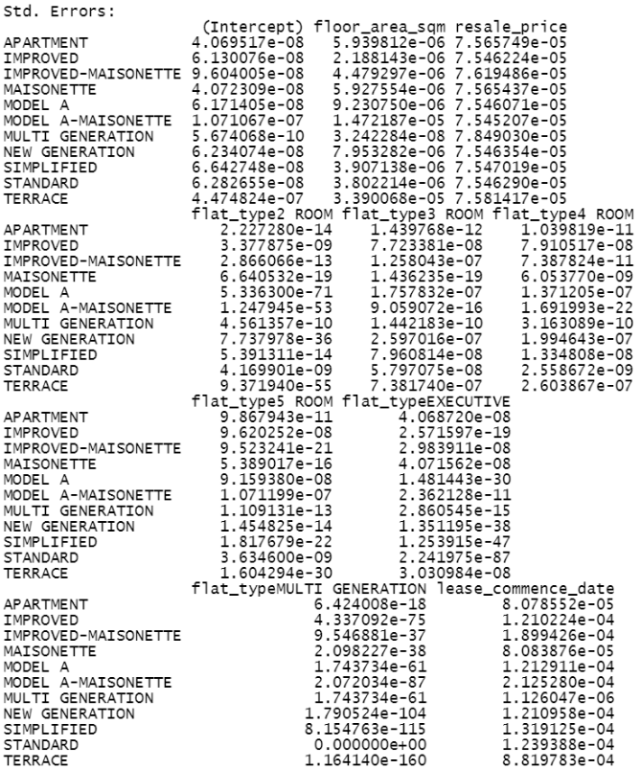
Standard flats have large positive coefficients for 2 to 5 rooms, telling us that 2 to 5 rooms are most likely to be associated with standard flats. Model A has a huge negative coefficient for 2 room flats, -244.43493, meaning Model A is less likely to be associated with 2 room flats. Model A has the biggest positive coefficient for lease commence date (0.7054), telling us that newer leases increase the probability of it being Model A.
We see that standard errors for most coefficients are very small, showing precise estimates. Additionally, we note that multi generation flat type has extremely small values, which may suggest that the dataset does not have enough multi generation flat type leading to data sparsity.

Comparison between Decision Tree and Multinomial Logistic Regression
Evaluate the performance for both techniques using confusion matrix.
Decision tree had an accuracy of 83.42% while logistic regression had 80.96%. This tells us that decision tree model is more accurate with its prediction by 2.46%. Kappa statistic for decision tree model is 0.7853 compared to 0.7552 for logistic regression model. This means that decision tree model shows a higher agreement between predicted and actual values for flat models. Sensitivity measures how well the model identifies actual positive cases. For decision tree, we observed that there is high sensitivity for improved, maisonette, model A, new generation and simplified flat models showing us that the decision tree model predicts this flat models well. However, there are some models that have 0.00 sensitivity, this could be due to the lack of data for these flat models in the dataset. Compared to logistic regression, decision tree seems to have worse sensitivity as logistic regression has lesser 0.00 values for sensitivity. Logistic regression has better specificity for simplified and maisonette but decision tree is stronger in major categories like new generation and model A flat models. We can create tables like below for easier comparison.
Specificity for each flat model | Decision Tree | Logistic Regression
Improved | 0.9137 | 0.9194
Maisonette | 0.9834 | 0.99148
Model A | 0.9846 | 0.9584
New Generation | 0.9490 | 0.8980
Simplified | 0.9608 | 0.99157
Decision Tree has higher balanced accuracy across most flat models compared to logistic regression. Overall, decision tree model performs better.
To improve our findings, we can use random forest for stability, or gradient boosting. We can also do feature engineering to further improve results.

Regression Technique
Research question: Can we predict economic loss due to food waste based on total waste, average waste per capita, population and household waste?
We will be using linear regression and random forest for this dataset. Linear regression can provide insights on how each variable impacts economic loss. It is simple and easy to understand. However, it assumes a linear relationship between economic loss and food waste. The data might have non-linear effects that the model is unable to capture. Random forest can capture non-linearity that we might not know is present.
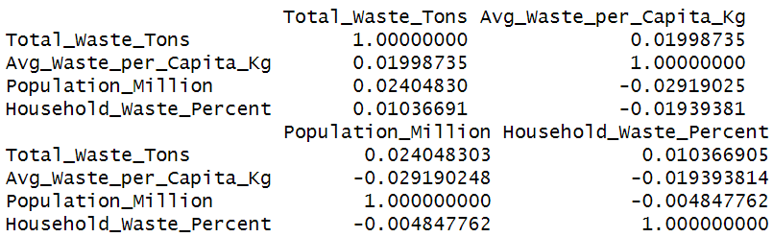
Firstly, rename the columns, making it easier to code and understand visualisations. Next, we remove rows with NA values. Afterwards, check the correlation between each variable. If any variables show a very high correlation (>0.9), we will have to either remove or combine the similar features. Looking at the correlation matrix, none of the variables have a very strong correlation. For example, total waste and average waste per capita has a correlation of 0.01998735, which is very low, indicating almost no relationship. This shows that multicollinearity is not present.
In this dataset, different variables have different scales, so we must scale the data. For example, total waste has much bigger numbers, in the tens of thousands as compared to household waste, in the tens. Scaling ensures that our variables are on a comparable scale, preventing variables with larger magnitudes, total waste, from disproportionately influencing the model. This will enhance the accuracy and reliability of the predictions made. Afterwards, select the variables we are using and split the data into training and testing sets. 80% will go to training set and 20% goes to testing set.

Multiple Linear Regression
It is multiple linear regression as economic loss is a continuous variable, and we are predicting economic loss using four independent variables.
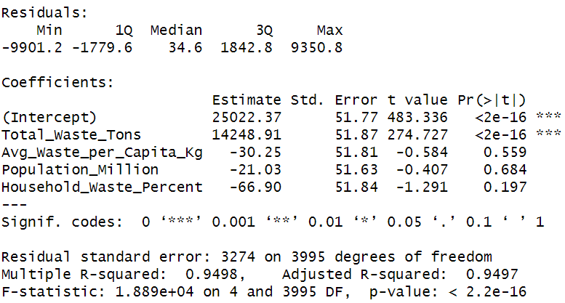
Build the linear regression model then view the summary of the model to retrieve coefficient estimates, p-values and R-squared values to assess the model’s performance. This helps us to determine which factors significantly influence economic loss. The model formula is ${Economic Loss= β}_{0}+β_{1}\left(Total Waste\right)+ β_{2}\left(Average Waste per Capita kg\right)+ β_{3}\left(Population\right)+ β_{4}(Household Waste Percent)$.
The model explains 94.98% ($R^{2}=0.9498)$ of the variance in economic loss, indicating a strong fit. Only total waste has a p-value < 0.001, telling us that economic loss is strongly driven by total waste amount. Average waste per capita, population and household waste are not statistically significant, meaning they do not have a strong impact on economic loss in this model. The intercept has a coefficient of 25022.37 which is large, this shows that even without food waste, there is economic loss. This could be due to other factors contributing to economic loss and the fixed cost in food waste management. Negative coefficients in the model means that as the variable increases, the economic loss decreases. However, this does not necessarily mean the predictor reduces economic loss. There could be government policies in place which reduce food wastage. Higher population also does not necessarily mean that there will be more waste. For example, when we compare Australia and India in 2019, with fruit and vegetables category, despite Australia (87.59million) having a much smaller population than India (1311.91million) the economic loss for Australia ($18686.68million) was much more than India ($11196.04million).
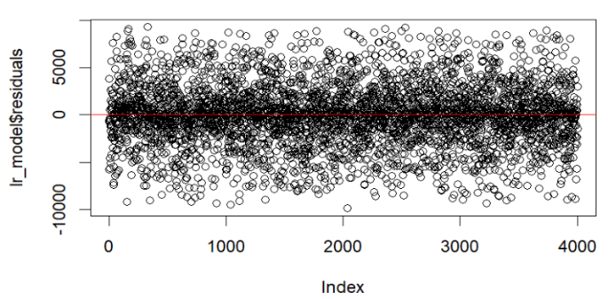
Plot a residuals plot to check if they are randomly distributed around zero. Add a red horizontal line to help identify any patterns in residuals. We observe that residuals are randomly scattered around zero, this means that the model does not consistently overestimate or underestimate economic loss.

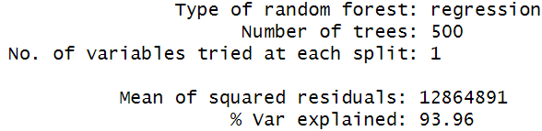
Random Forest
Build the model then check the model’s performance. 500 decisions trees were used to make predictions, ensuring stability. We observed that at each split, only one variable is considered for splitting which is quite low. However, as seen from linear regression, we found out that total waste is the only statistically significant variable. 93.96% of the variance in economic loss is explained by the model, suggesting a strong fit.

Comparing Multiple Linear Regression and Random Forest
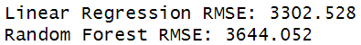
To compare which model is better, we compare by the model’s root mean squared error (RMSE), where the model with lower value is better. Linear regression has a RMSE of 3302.528 while random forest RMSE has 3644.052, a 341.524 difference. Additionally, linear regression model was able to explain 94.98% of the variance in dataset while random forest explains 93.96%. Thus, linear regression is a better model.

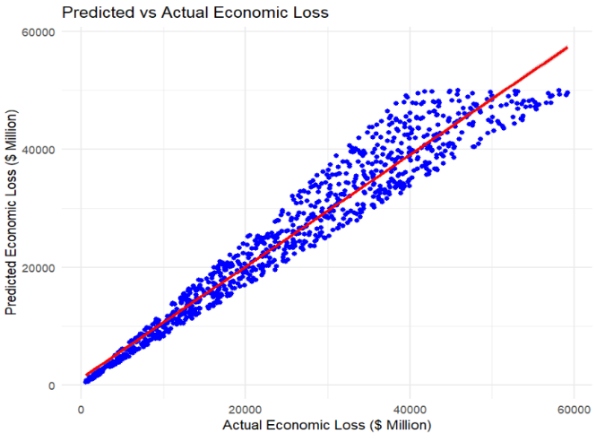
Predictions with Multiple Linear Regression
Plot a graph to show predicted values from linear regression model to the actual values. Red line represents the regression line. We observe that most of the points are centered around the regression line. However, as actual economic loss increases, the predictions tend to be less accurate. This tells us that the model’s predictive power decreases as economic loss increases. It might not be capturing all the important factors that influence economic loss. Important factors could be government policies, inflation or food demand which is not known from the dataset. This led to the model struggling for higher values of economic loss.

Additional Check
To determine whether the three other variables were strongly contributing to or being absorbed into total waste (tons), we need to conduct a regression analysis with total waste as the target variable. This allows us to assess whether average waste per capita, population, and household waste percentage significantly explain variations in total waste. We will perform the same steps as linear regression, however, we only scale average waste per capita, population and household waste percentage.
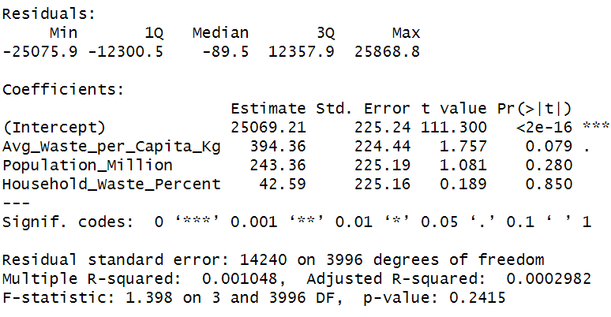
From the results, we observe that the adjusted $R^{2}$ is 0.0002982, which is extremely low. This indicates that these 3 variables explain almost nothing about the variation in total waste. The p-values for the 3 variables are all above 0.05, none of them significantly influence total waste. The three variables are not absorbed into total waste.

Conclusion
For unsupervised learning, we found out we can cluster houses by flat types. The technique best suited for this question was k-means clustering. Using more years from the dataset might improve the results but due to computer constraints, running 2 years is the most feasible option. Having more years will allow us to gather more insights into the dataset. Additionally, try out k=7 and k=9 clusters as they are ‘elbows’ as shown in the graph that finds optimal number of clusters.
For classifications techniques, we predicted the flat model based on features like floor area, resale price, lease commence year and flat type. The technique best suited for this question was decision tree. Using more years would also be better.
For regression techniques, we predicted economic loss due to food waste based on total waste, average waste per capita, population and household waste. The best technique was linear regression for this question. However, I recommend adding variables such as inflation, government policies on food waste, regional economic conditions so that we know more context and improve the model accuracy. We can also segment the model by country or food category to have more precise predictions. Different countries have different economic structures, policies and food waste management which could affect economic loss differently. Different food categories may have different economic loss impact due to costs or perishability. For example, fruits and vegetables might perish faster than frozen food.
Lastly, in the codes, functions such as head(Fooddf), serves a crucial role in inspecting the data frame. Their main purpose is to identify any missing values and provide us with an overview of the dataset before proceeding with analysis. This step is essential as we need to work with clean and accurate data. Overlooking these errors at this stage could lead to incorrect results.

References
- Singapore Housing Map: Singapore HDB Statistics, facts & figures - Singapore Housing Map
- Housing & Development Board: HDB | Types of Flats
- Shashi Kumar, 2024: 3STD, 3I, 3S, 3NG, 3A: Guide To Understanding The Different Variations OF 3-Room HDB Flats

https://data.gov.sg/datasets/d_ebc5ab87086db484f88045b47411ebc5/view
https://www.kaggle.com/datasets/atharvasoundankar/global-food-wastage-dataset-2018-2024

